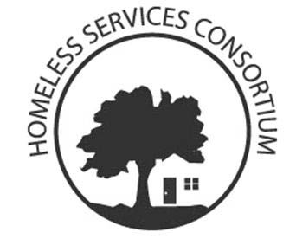
Homeless Services Consortium

Tuesday, August 7th, 2018
12:00 p.m. – 1:30 p.m.
First United Methodist Church
203 Wisconsin Ave, Madison, WI 53703

AGENDA

- Dream Up Wisconsin- 25 min Bridget Van Belleghem
- Introductions- 3 min Melissa Mennig
- Small group brain storming ideas- 15 min Everyone
- Access to Independence- 20 min Michelle Cordova
- Board Update- 5 min Takisha Jordan
- NOFA Update- 20 min Torrie Kopp Mueller
Built For Zero Update
NAEH- Hill Day Summary
- Announcements- 2 min Everyone

Committee Meetings This Month:
1. Core Committee- 1st and 3rd Thursday of the month 1-3 pm.
a. Thursday, August 16th TBD location
2. Education and Advocacy Committee- 3rd Wednesday of every month 9-11 am.
a. Wednesday, August 15th The Road Home- New office- 890 W Wingra Dr,
3. Shelter Providers Committee- First Wednesday of every even month
a. Wednesday, September 5th, 2018 9:00am-10:30am at the Beacon
4. Funders Committee- 1st Tuesday of the month
a. Tuesday, September 4th, 2018 10:30am at United Way
5. Point-In-Time Committee- Meets as needed
6. Community Plan to Prevent and End Homelessness Oversight Committee- Not scheduled
7. Nominating & Governance Committee- Meets as needed
8. Committee to End Youth Homelessness- Not scheduled.
9. City County Homeless Issues Committee- 1st Monday of the month
a. Monday, September 3rd , 6:30 City County Building third floor

If you are interested in attending a committee please contact the committee chair before the meeting. (see website or email chair or co-chair)
- If you would like to be added to the HSC List Serve Please email hsc@cityofmadison.com
- If you have announcements or changes for committee meetings please email the list serve

Questions/ Want to present? Email Melissa Mennig Chair melissam@trhome.org

