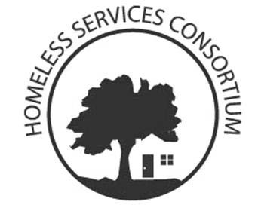
Homeless Services Consortium

Tuesday, September 4th, 2018
12:00 p.m. – 1:30 p.m.
United Way of Dane County
2059 Atwood Ave, Madison, WI 53704

AGENDA

- Introductions- 3 min Melissa Mennig
- Board Update- 2 min Jani Koester
- Election Process- 15-20 min Torrie Kopp Mueller
- Coordinated Entry Update-30-35 min Katie Spaeth
Maggie Carden
- System Performance Presentation- 30 min Torrie Kopp Mueller
- Announcements- 5 min Everyone

Committee Meetings This Month:
1. Core Committee- 1st and 3rd Thursday of the month 1-3 pm.
a. Thursday, September 6th and 20th TBD location
2. Education and Advocacy Committee- 3rd Wednesday of every month 9-11 am.
a. Wednesday, September 19th The Road Home- New office- 890 W Wingra Dr,
3. Shelter Providers Committee- First Wednesday of every even month
a. Wednesday, October 3rd, 2018 9:00am-10:30am at the Beacon
4. Funders Committee- 1st Tuesday of the month
a. Tuesday, October 2nd, 2018 10:30am at United Way
5. Point-In-Time Committee- Meets as needed
6. Community Plan to Prevent and End Homelessness Oversight Committee- Not scheduled
7. Nominating & Governance Committee- Meets as needed
8. Ending Youth Homelessness Committee- 3rd Monday of the month from 1:00p-2:30p
- Monday, September 17th 1-2 pm at First United Methodist Church
9. City County Homeless Issues Committee- 1st Monday of the month
a. Monday, October 1st, 6:30 City County Building third floor

If you are interested in attending a committee please contact the committee chair before the meeting. (see website or email chair or co-chair)
- If you would like to be added to the HSC List Serve Please email hsc@cityofmadison.com
- If you have announcements or changes for committee meetings please email the list serve

Questions/ Want to present? Email Melissa Mennig Chair melissam@trhome.org

